Bi-monthly News, Views & Comment from inside and out the Royal Edinburgh Hospital
‘Stories of Changing Lives’
Monday, 1 February 2010
2.00 – 3.00 pm
Board Room, Royal Edinburgh Hospital
We will be launching our powerful and inspiring publication ‘Stories of Changing Lives’. All Royal Edinburgh Hospital patients, staff and carers
are welcome to attend.
Patients are welcome to remain for a brief Patients Council Meeting
from 3.00 – 3.30pm.

Refreshments will be provided

WELCOME
Our last Patients Council Meeting

Nine members attended our last Patients Council Meeting on 28 September 2009.

- Several members said how much they used to value a member of the Individual Advocacy team attending our meetings. We agreed to invite them to attend again whenever we or they feel it would be helpful.
- We continue to achieve results through the Acute In-Patient Forum, such as upgrading bathrooms. We are busy establishing collective advocacy meetings on rehabilitation wards. We learned that the Releasing Time to Care and Star Wards initiatives are trying to help staff find our time to spend talking to patients.
- AdvoCard is the new host agency for the Patients Council. This means they take on the employer role for us and provide assistance and advice at our request.
- We heard about our meeting with Non-Executive Directors of NHS Lothian Board in September. This was a very encouraging meeting and we have received very positive feedback from them.
- John Armstrong, Joint Programme Manger for Mental Health, joined us to explain his role, which involves ensuring that the NHS and City of Edinburgh Council work together to provide services, and looking after jointly-funded mental health services such as accommodation, advocacy, counselling and supported employment services. John is very keen to hear the views of Patients Council members.
- Some new issues were brought up, including lack of communication about discharge meetings; issues around smoking in the hospital; people having to go into hospital repeatedly because they treatments are not meeting their needs.

Annual General Meeting 2009

25 people attended our Annual General Meeting in the Board Room on 30 November.

Our speakers were Susan Tennyson and Andy Wills. Susan told us about her new Senior Charge Nurse/Advanced Practitioner role which has included working on the Star Wards initiative, Personal Recovery Files and the Festival Stories programme. She supports and mentors newly qualified nurses and provides clinical supervision for staff. She is looking forward to working closely with the Patients Council in 2010 and would particularly like to revive the Safety, Privacy & Dignity meetings.

Andy now looks after ‘Releasing Time to Care’. He was shocked to discover that nursing staff on mental health wards spend only 25% of their time on direct patient care. Although it is very difficult because of the state of the current REH buildings, ‘Releasing Time to Care’ aims to improve this by identifying how wards work; helping staff to come up with a ‘vision’ of how they want the ward to be (for example, safe, clean, more activities for patients and more direct care); providing tools to measure these; and reorganising wards and procedures to help these changes to happen. We wanted staff to have more time to talk to patients and to escort patients off the wards; more robust washers and driers; less ward rounds and more individual appointments with consultants; and patients to be involved in their care plans.

Project Manager David Budd highlighted some of our recent work, including Kaizen work with the hospital, visitors from China, Governance training and hosting pan-Lothian collective advocacy forums. It has been a very busy and positive year for the Patients Council.

Kate Cullen, Elaine Dobbie, Shirley Gowers, Ian Hughes, Charlotte Mitchell, Albert Nicolson, Alison Robertson and Patricia Whalley were elected as members of our Management Committee.

Maggie Keppie and Tom Carey both announced their retirement from mental health volunteering.

Within the Hospital

Acute In Patient Forum – The forum continues to be a good place to raise a variety of issues. The Patients Council continues to raise issues brought to their attention by patients. Patients make the Patients Council aware of issues in different ways like Collective Advocacy Meetings on wards and the Patients Council Open meeting held in the Board Room very 2 months. Some issues raised and discussed were:
- Plans for the alteration to staff and patient rooms on Meadows Ward
- Question about revolving patients and
- Issues about discharge procedures.
VOX, CAPS and Individual Advocacy all had similar examples of experiencing the same issues.
Collective Advocacy on Rehab Wards – For some time now we have held collective advocacy meetings on Ettrick and Craiglea. We have dates for Swanston and will soon be starting to hold meetings on North Wing. These meetings wouldn’t work as well without the support from ward staff. We would like to thank them for their support and look forward to working in partnership with all the rehab wards and lending them our support throughout 2010 for the benefit of Patients and Staff at the REH.
New protocols between Individual Advocacy and the Patients Council – For some time now the Patients Council and Individual Advocacy have worked in partnership for the benefit of Patients and Staff at the REH. This close working relationship has recently benefitted from the projects looking at how they might improve this. The result was a ‘protocol’ or working agreement. The protocol sets out just how the two projects can work together more seamlessly. One or two of the points in the protocol are:
- regular monthly handover meetings where collective issues and themes can be officially passed on to the Patients Council
- the use of collective advocacy referral and tracking forms
The Patients Council will also produce a list of current topics for a bulletin board which Individual Advocates can take to their drop-ins, offering patients the opportunity to feed back on such diverse subjects as the rebuild of the hospital and smoking. These and many other measures mean both projects work in harmony and squeeze as much out of their resources as possible and give as much opportunity to patients to feed back on important topics and development which affect in-patient care.
Care of the Elderly wards and Children & Adolescent Mental Health Services (CAMHS)
We have received funding from the hospital to extend collective advocacy services to these two areas for 12 months. We are busy planning how best to provide these services. Maggie McIvor will split her time between development work and her current administrative work. If you have any feedback or would like to raise any issues about Care of the Elderly or CMHS, then please contact Maggie at the Patients Council office.
Partnership working with Estates
We are all enjoying working with Lesley Hunter from Estates. Our volunteers are visiting wards with Lesley and a number of issues have been identified and successfully dealt with.

Patients’ Council
Issue 7 / Page 2

Patients’ Council Exhibition!
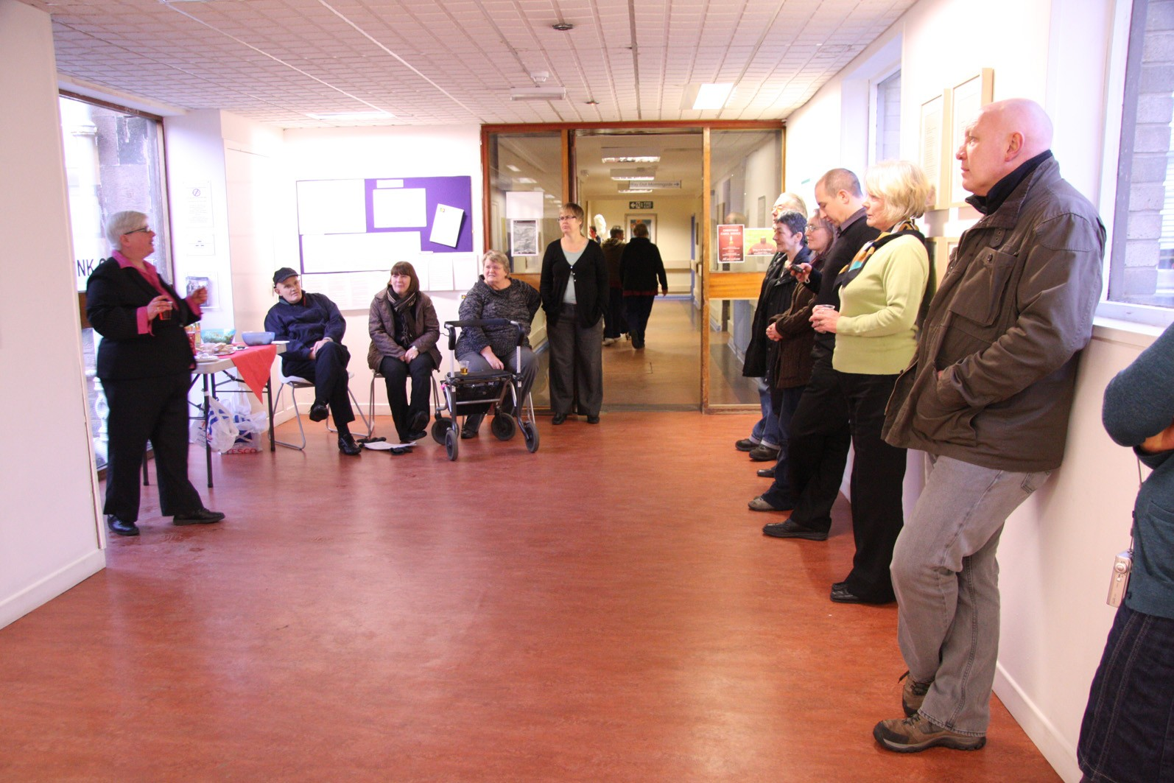
The Patients’ Council is the subject of the current exhibition in the Artlink Corridor which leads to the Andrew Duncan Clinic in the hospital. Artlink have done a terrific job creating panels which capture some of the thoughts and feelings of both current and former members and staff. There are panels which tell you a bit about the origins, history and achievements of the Council. There is an information board about our work. Lots of fantastic art work from some of our members is also on display.
Thank you to Artlink staff for offering us such an interesting opportunity and doing such a great job making it happen!
Some of our work in 2009
Rooms open on Orchard Clinic
Involved in Day Services Review Kaizen
Ward visits with Estates Department
Strategic Development Group
Nutrition Group
Acute In-Patient Forum
Collective Advocacy Drop-Ins on Rehabilitation wards
Endowments Grant – through Tim Montgomery – to provide collective advocacy in older and younger services for 12 months
Bi-centenary and all sub-groups
Choose Life – suicide prevention work
ICP’s
Smoking Cessation steering group and smoking policy in the Royal Edinburgh Hospital
Edspace Advisory Group
Acute models of care
Safety Privacy & Dignity
Visit from the non-executive members of NHS Lothian
Transfer of patients at age 65 as opposed to need
Disability and equality of access review group
Government consultation on smoking in psychiatric hospitals
Reprovisioning (rebuild) workshop
Star Wards
Orchard Clinic Collective advocacy meetings

Join us in 2010 as we continue our work to achieve better
in-patient services and experience for staff and patients

Patients’ Council
Issue 7 / Page 3
Stories of Changing Lives Launch

Over 70 people attended the launch of our new publication, ‘Stories of Changing Lives’, at Napier University’s Craig House campus on Friday 15th January. The Patients’ Council was set up 30 years ago to support patients who were moving to the Royal Edinburgh Hospital when Craig House closed.

‘Stories of Changing Lives’ is a collection of interviews with patients, carers and staff sharing their personal experience of moving from hospital based care to community care. It enables them to tell their own stories in their own words and to have their stories acknowledged. The work was ably led by Lesley Smith, a member of the Patients Council. Lesley sums up the key messages from these powerful narratives: “Some people would say that community care doesn’t work but we ask you to think again: these stories prove that community based care is focussed, well-planned and resourced in a person-centred and holistic way. It enables people to be in control of their lives showing that it can and does work.”

Further free copies are available from the Patients Council

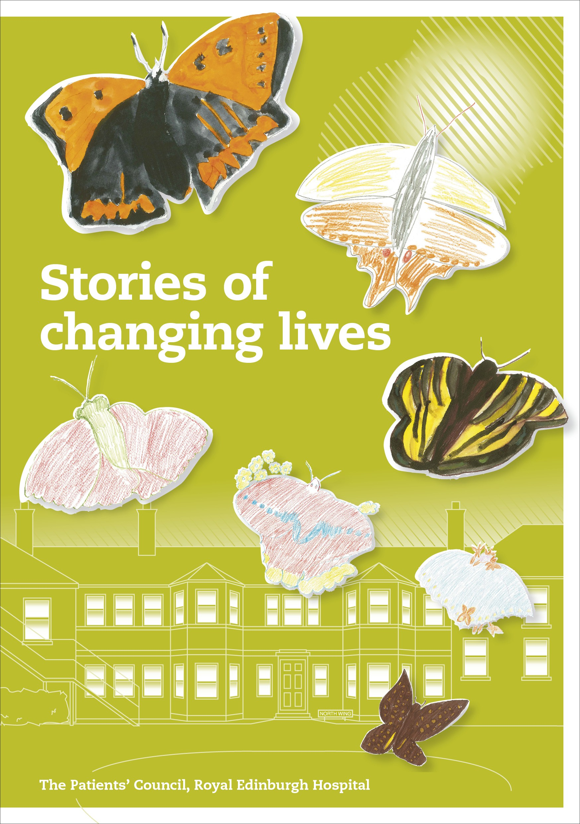

Patients’ Council
Issue 7 / Page 4
The Royal Edinburgh Hospital Supported by AdvoCard Funded by:
Patients’ Council
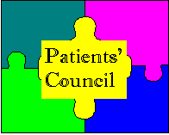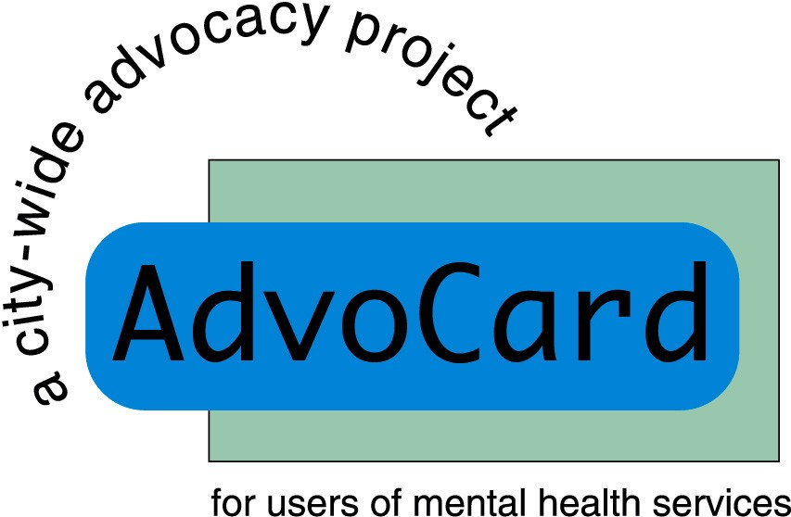

The Patients’ Council is a registered charity, Scottish Charity No SC021800
Our offices are situated off the Link Corridor in the Andrew Duncan Clinic
Website: www.patientscouncilreh.co.uk

The Royal Edinburgh Hospital Patients’ Council
is an independent collective advocacy organisation. Our members are people who are using or have used the services of the hospital. We provide a forum for common issues on mental health treatment and care and represent patients’ interests in order to improve services. Everyone is welcome to come along to the bi-monthly general Patients’ Council Meetings.

To receive the Newsletter direct, by post or e-mail, contact Maggie McIvor, Admin Worker.
To get involved with mental health issues from the service-user’s viewpoint, contact
David Budd, Project Manager.

Telephone: 0131 537 6462
Email: maggie.mcivor@patientscouncilreh.org.uk
david.budd@patientscouncilreh.org.uk
Write: The Patients’ Council, Royal Edinburgh Hospital, Morningside Terrace, EH10 5HF

Our Management Committee:
Patricia Whalley (Chair); Elaine Dobbie (Convenor of Management Committee); Alison Robertson (Vice Chair), Kate Cullen, Shirley Gowers, Ian Hughes, Marie Jenkins, Carol Manley, Charlotte Mitchell, Albert Nicolson. Co-opted members: Cathy Robertson, Leah Marchbank, Ross McPhail, Alan Muir
Patients’ Council Meetings 2010
Mondays : 2 – 3.30pm : Board Room
1st February, 22nd March, 24th May, 2nd August and 27th September
Annual General Meeting 2010
1.30–4pm : Board Room
Monday 29 November

Ecumenical Service
A 30 minute service, with tea/coffee and biscuits, is held every Sunday in the Hive at 10.15 am. Relaxed and friendly. Open to everyone. Holy Communion on the first Sunday of every month. Please also ask for guidance in other denominations.
Useful Contacts:
- ADVOCARD: an individual advocacy service for service users who live in the community TEL: 0131 554 5307 / 475 2340 www.advocard.org.uk
- HOSPITAL ADVOCACY: an individual advocacy service for in-patients of the hospital Tel: 0131 537 6004
- EDINBURGH CARERS COUNCIL: Tel 0131 270 6087 www.edinburghcarerscouncil.co.uk
- EDINBURGH USERS FORUM: a collective advocacy group for people who use, or have used mental health services Tel: 0131 538 7177 www.edinburghusersforum.org
- EDSPACE: a mental health information website Tel: 031 243 0106 www.edspace.org.uk
- LAW SOCIETY: Tel 0131 226 7411 www.lawscot.org.uk “Find a solicitor”
- LEGAL SERVICES AGENCY: a solicitor for people who use mental health services Tel: 0131 228 9993
- MENTAL WELFARE COMMISSION
Advice Line: 0800 389 6809 or 0131 313 8777 www.mwcscot.org.uk
- REH CITIZENS ADVICE BUREAU: free advice on benefits, employment, family, immigration, housing, money matters re patient/staff concerns Tel 0131 537 6399/6843 www.cas.org.uk
- SCOTTISH RECOVERY NETWORK: Tel 0131 240 7790 www.scottishrecovery.net
- VOXSCOTLAND: National service user network Tel: 0141 572 1663 www.voxscotland.org.uk

