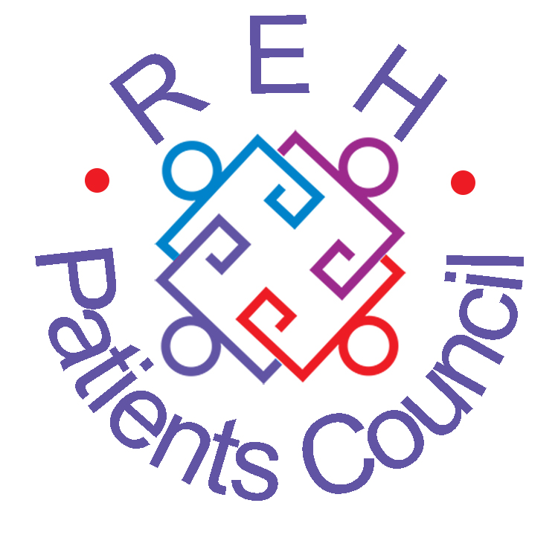
PATIENTS COUNCIL NEWSLETTER
July 2015
NEWS, VIEWS AND COMMENT FROM THE ROYAL EDINBURGH HOSPITAL
Patients Council Meeting
Monday 25 May 2015
14 people attended an informative, stimulating and enjoyable informal question and answer session with Linda Irvine, NHS Lothian’s Strategic Programme Manager for Mental Health. Linda does a lot of thinking, planning and gathering ideas on how to improve the mental health and wellbeing of people of all ages across the Lothians.

NHS Lothian is involved in a number of Public Social Partnerships (PSPs), a new way for statutory and voluntary organisations to work in partnership. GreenSpace ArtSpace has been asking lots of people what they’d like to see in the grounds of the new hospital. The newest PSP is GameChanger, working with Hibernian Football Club – it’s about both physical and mental health which should help to reduce stigma and discrimination. The annual Taking Stock conference reviews current projects and seeks new ideas. The Scottish Government has promised more money for mental health, to achieve parity with physical health.

We discussed the smoking ban. One member pointed out that it persecutes smokers who can’t get off the grounds, so they don’t have the same rights as others. People feel their mental health is suffering and they miss the social aspect of going out for a cigarette with others. The Patients Council argued the case strongly, especially regarding enforcement, but the ban is national policy. The only effective route may be a legal challenge.

Funding has been sourced to redevelop The Hive and employ an Arts Manager at the Royal Edinburgh Hospital. The GreenSpace ArtSpace PSP will ensure that there are plenty things available in the grounds for people to do. Groups are being set up to take this forward. The Patients Council will have a seat on each group.

We asked Linda about the future of collective advocacy. Linda stressed the importance of collectiveness – organisations like AdvoCard and CAPS speak for all people with lived experience. We need to use creative ways to gather views, such as Stories of Changing Lives.
Stories of Changing Lives II

Simon and Ronnie launched our new booklet, Stories of Changing Lives II, at the Taking Stock conference on 28 May. The day was a great success for us and a great way to distribute hundreds of copies to a wide audience. Simon offered a thoughtful overview of the background to producing the book and Ronnie thrilled the audience with his excellent readings of a story and a poem from Stories of Changing Lives II.

We’re going to hold another launch in the hospital for all patients, staff and visitors on Monday 13th July. Please come along!

The Patients Council,
Royal Edinburgh Hospital

launch of

Stories of Changing Lives II

Link Gallery
Royal Edinburgh Hospital

2pm on Monday
13th July

Everybody welcome!
Refreshments will be provided

www.rehpatientscouncil.org.uk Page 2

Group Advocacy
In May and June we:

- Listened to a lot of complaints about the impact of the new smoking ban on patients throughout the hospital. Patients in the Orchard Clinic feel the new policy hits them particularly hard: they see lots of people freely smoking on the grounds with no consequences, but because of rules on nurse escorts, they are unable to smoke on or even off the grounds. Patients in wards like Craiglea and Eden complained about how far they have to walk to get to a hospital exit – not so easy if you are older or have mobility issues. These patients feel like the policy unfairly discriminates against them. Patients in Meadows and IPCU created smoking ban petitions which we sent to the hospital manager. Smoking on the wards remains a major problem.
- Strongly represented the collective voice of Rehab patients at the Wayfinder PSP groups, which are redesigning rehabilitation services in the REH and the community. It looks likely that a house in Colinton Mains (called Firrhill) will open in October to take 6 patients from the Rehab wards. We have stressed the importance of patients’ rights in the design of this project and asked lots of questions about how patients will benefit from a move to a different type of team and model of care than the one they are familiar with.
- Attended a very interesting event on the Open Dialogue approach to mental health care that started in Western Lapland in Finland, but is quickly spreading to the UK, New York and the rest of the world. Open Dialogue uses a psycho-social approach and focuses on a person’s family and social networks and the ideas that there is meaning in psychosis which can be uncovered by dialogue between people. It’s a completely alternative system of mental health care which claims it can reduce the use of medication and compulsion. Could it work here?

Mirror Image by Jo McFarlane
Published in Stories of Changing Lives II

This is what I want Can find the love
to be: a carbon copy within, Your beauty’s
print of me in your suffering

A billboard plastered So don’t deny it,
high above: my picture on it, don’t belie it, don’t escape
look of love on drugs or diets

This is what I want Look your mirror
to write: my signature in the eye, cry your tears
bold and wide then wipe them dry

A book about my tawdry life: Only then you’ll find your wings
the tears I’ve wept, Fly my child towards the sun
the rope, the knife You can’t go back, you won’t go wrong

This is what I want
to show you: how I’ve grown,
how I know that you
www.rehpatientscouncil.org.uk Page 3

The Royal Edinburgh Hospital
Patients’ Council
The Patients Council is an independent collective advocacy project for people who use or have used the services of the hospital. We provide a forum for common issues about mental health treatment and care and represent patients’ interests in order to improve services. We hold general meetings every two months. To get involved with mental health issues from the service-user’s viewpoint, contact our staff.

Telephone: 0131 537 6462
Email: info@rehpatientscouncil.org.uk

Write: The Patients’ Council, Royal Edinburgh Hospital, Morningside Terrace, EH10 5HF

Our Management Committee
Shirley Gowers, Ronnie Jack,
Albert Nicolson, Martin McAlpine, Alison Robertson, Ralph Turner, Patricia Whalley

Co-opted member:
Cathy Robertson
PATIENTS COUNCIL MEETINGS
2015
2 – 3.30pm

26 January

23 March

25 May

27 July

28 September

30 November:
Annual General Meeting
1.30 – 3pm in The Hive
followed by buffet

History of the Patients Council
A few of our members have written a history of the Royal Edinburgh Hospital Patients Council highlighting some of our activities since 2000. Please contact us for a copy.

To receive the newsletter direct, by post or e-mail, please complete and return this section.
I would prefer to receive the Newsletter by post □ email □ (tick as appropriate)
Name ____________________
Address_______________________________________________ Post code_____
Email__________________________________________________________________________

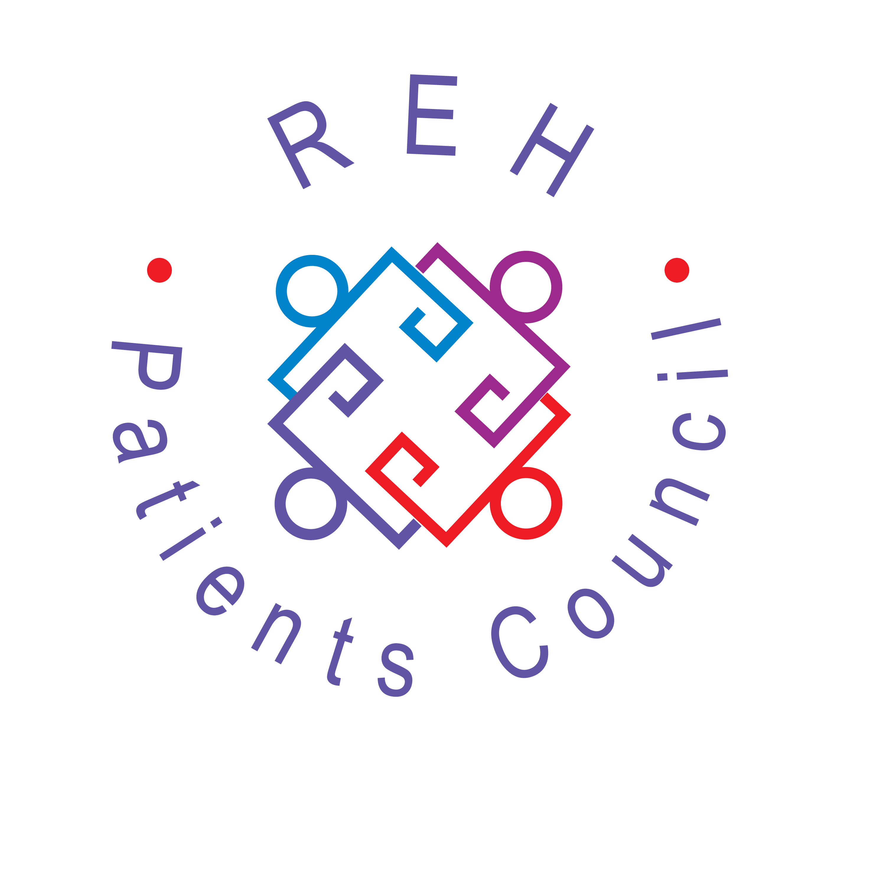
The Royal Edinburgh Hospital Patients Council is a registered charity
Scottish Charity No SC021800
Our offices are between Outpatients and Mental Health Tribunal in the ADC
www.rehpatientscouncil.org.uk

All patients, former patients, staff and visitors are warmly invited to attend

PATIENTS COUNCIL MEETING

from 2.00-3.30pm on

Monday 27 July
in The Hive

Our guest speaker will be
Paul Noyes
from the Mental Welfare Commission for Scotland

www.rehpatientscouncil.org.uk

