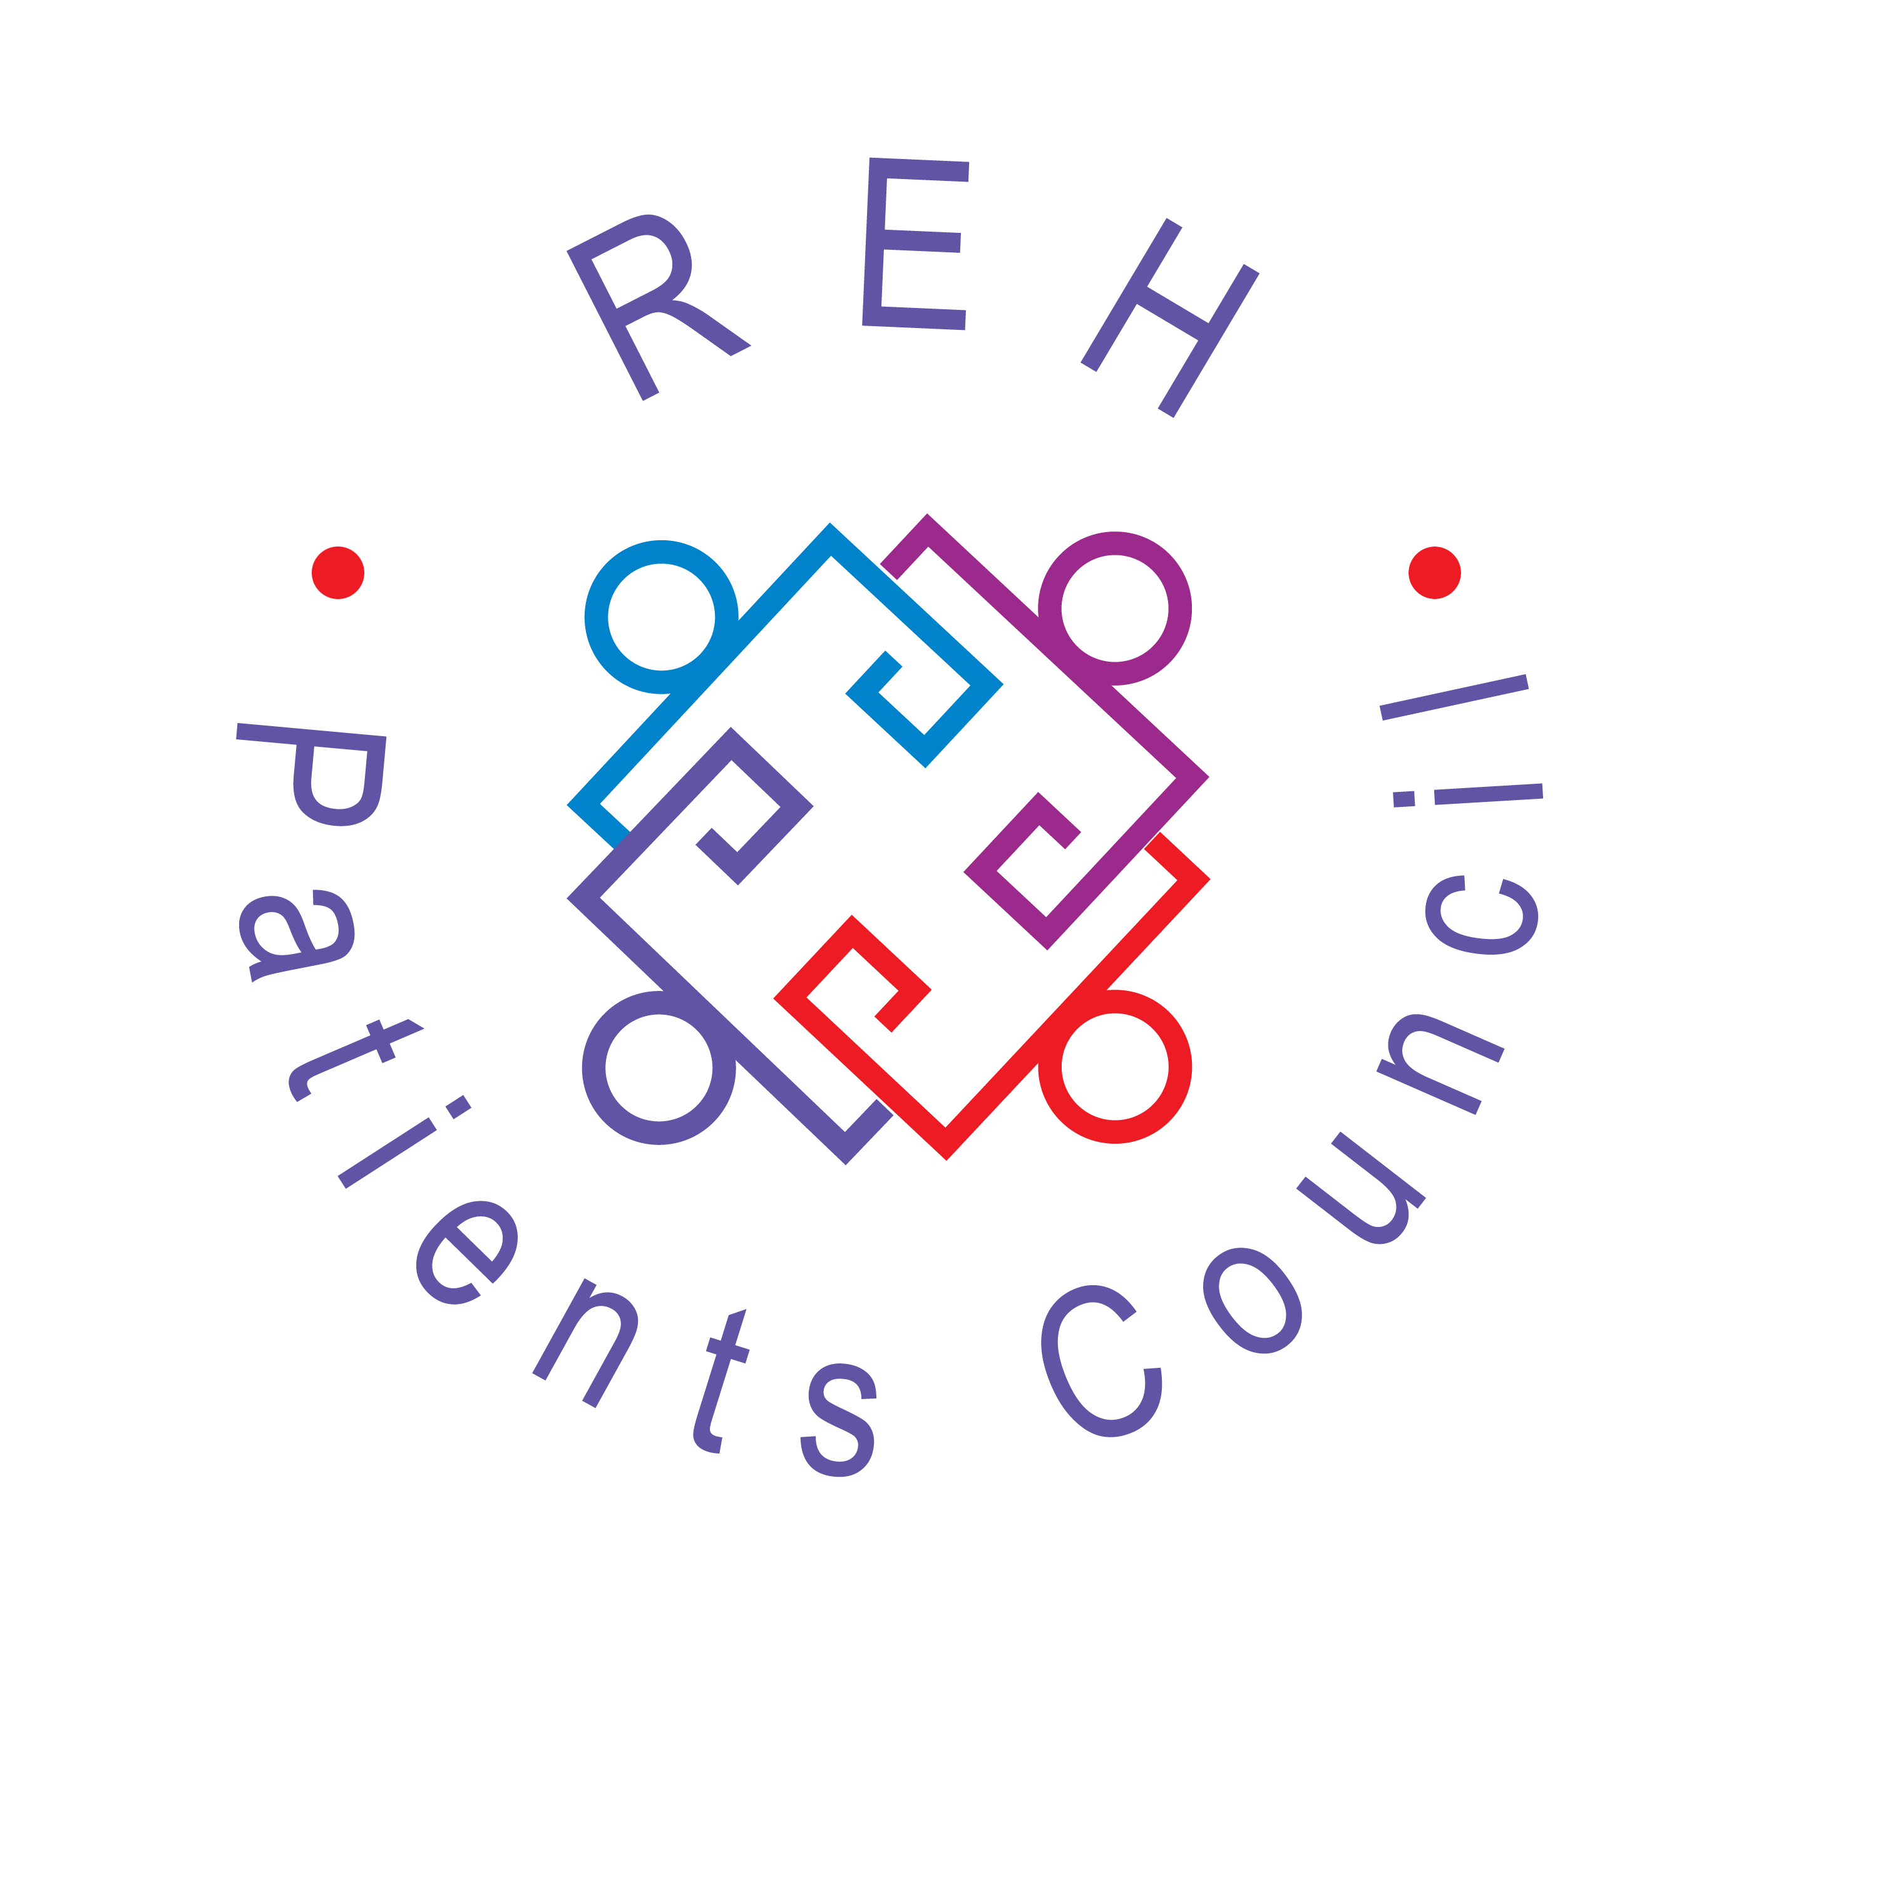

All patients and former patients of the Royal Edinburgh Hospital are warmly invited to attend the

PATIENTS COUNCIL MEETING
from 2.00-3.30pm on
Monday 27 May 2013
at The Hive

Lorna Martin, Chief Nurse in the hospital, will be telling us all about her experiences in Afghanistan last year

Please join us for a cuppa!
WELCOME TO NEWS, VIEWS AND COMMENT FROM THE ROYAL EDINBURGH HOSPITAL

Our last Patients Council Meeting
Monday 25 March 2013

Cathy Burns from Sainsburys Try Team came along to do a cookery demonstration for us. We had asked Cathy to show us how to make some quick, easy and affordable meals, cooking for one, and using an ingredient in more than one dish. Cathy did an absolutely fantastic job, keeping us thoroughly entertained while showing us how to make two healthy, tasty and nutritious main courses and two puddings very cheaply and easily. And we got to taste them afterwards – totally delicious!

These are some of the comments made by people who attended the session:

“Fantastic – simple, easy recipes, not expensive, mostly using the Sainsburys Basics range.”

“Really gave me ideas to get out of the rut I’m in.”

“Good to know the cheap range is good nutritionally, not full of rubbish.”

“That was really good.”

“Especially liked the fritters – great for breakfast – and the recipes are easy to adapt for vegetarians.”

“Absolutely wonderful – and so much effort carting all that stuff to do a demo for us!”

“Not only delicious, really informative.”

“Cathy is really enthusiastic about what she is doing and so good at her job – the food was quality and tasty.”

www.rehpatientscouncil.org.uk
Page 2

Acute and Rehab Wards

We are really pleased that all acute patients will have access to secure storage in key-pad entry safes. Safes were installed by the hospital on all the acute wards in April. We would like to thank Lorna Martin and Andy Wills for responding so positively to the patients’ needs for secure storage. Patients will benefit greatly from keeping items safe on the wards.

Our volunteers have been attending the Clinical Brief and Design Task Group meetings. The work has progressed from an overview of the first phase through to 1:200 scale designs. Our volunteers have been able to feed in patient perspective on what’s needed from the new hospital. So far, we have been impressed with the design team and their willingness to hear the feedback and incorporate it into the new design.

Between March and April this year Ettrick patients moved out of the hospital into accommodation which suited their individual needs. We want to wish those patients well in their new homes. We worked closely with hospital management, CRT, individual advocacy and the Carers Council to address any concerns that were raised about patients moving from Ettrick. Swanston patients will now move into Ettrick to form a new ward which is now called ‘Albany’.

Younger and Older People
Ward staff and Estates do everything possible to try to minimise problems caused by the ancient plumbing system. On Eden Ward, we have been speaking to patients individually, which seems to work better than a group meeting. Some patients would like to see their consultants more often, and can get a bit bored on the ward. But in general patients are very happy with the care they receive on both Comiston and Eden. Young people in the CAMHS In Patient Unit would like more structured activities, especially in the evenings. They speak highly of the staff and believe they receive a high standard of care on the unit.

History of the Patients Council
A few of our members have written a history of the Royal Edinburgh Hospital Patients Council highlighting some of our activities from 2000 to 2011. If you would like us to send you a copy, please phone Maggie on 46462, or email us at info@patientscouncilreh.org.uk.

WE HAVE MOVED
Our new offices are in the Outpatients corridor just in front of the Tribunal Suite doors.

Nurse Education – Opportunities and Development

The Patients Council has once again shown just how versatile and innovative its members can be when it comes to forging links with student nurse education. Two members of the Council have now for the second year been to deliver a lecture and workshop at Edinburgh University. Alongside links to other nurse education institutions this involvement allows the students to develop a real opportunity to hear about service provision, from the service user’s perspective. Service user involvement is a key element within current pre- and post-registration nurse education in the U.K. but achieving this is challenging, however these face to face discussions provide a richer experience for the students enabling them to reflect more deeply on how nursing care is delivered and perceived by service users.
With the involvement of service users and carers in nursing education students can learn to treat people as individuals and work with them as partners to support their health. They can also recognise the value of patient and carer experience alongside broader medical evidence and become well prepared to work in a world where patient and public involvement is a normal part of how health services are run.

Effective progress requires a broad strategy to involve service users and carers in all aspects of the educational process (not just coming in for one or two teaching sessions). This may involve Service users and carers in:
• direct delivery of learning and teaching • course / module planning
• programme management • recruitment and selection of students
• practice learning • student assessment
• course evaluation • joining courses as participants

Hopefully these challenges will be met in the future and the relationship between the Patients Council and the Higher Education Institutions will only go from strength to strength. It however cannot be stressed enough the stalwart work, dedication and unwavering determination of the Council’s volunteers to develop these links with the nurses of the future. I stand back in awe of the honesty, humility and the sheer humanity of these amazing individuals who talk about great difficulties they have experienced with humour, understanding and insight into the benefit that others may derive from their stories. Perhaps it is best to finish with a quote from one of the students who after Alison and Albert’s visit said how brave she thought they were.
” It’s one of those little things that changes everything, when we can see the humanity in our patients, when we remember why we wanted to be nurses in the first place”

Jo Dunlevie, teaching fellow Edinburgh University

www.rehpatientscouncil.org.uk

Page 3

 Yoghurt, Cucumber & Mint Dip

Ingredients: Method:

125ml low fat natural yoghurt Combine all ingredients in a bowl and serve
- ¼ cucumber, cut into small dice with sticks of celery, carrot, cucumber,
- Dessertspoon of freshly chopped mint, or tsp dried mint peppers and wholemeal pitta bread
----------------------------------------------------------------------------------------------------
Bring this recipe along to the fruit stall in MacKinnon Building and get your free cucumber and mint with any purchase.
Every Tuesday from 8am till 2pm for the month of June 2013 only.

Towards an Edinburgh Autism Plan is now live, full details available at www.edinburgh.gov.uk/autismplan - a plan for children and adults who have autism who do not have a learning disability. We are planning two open consultation session for people with autism and / or their carers. The dates are –
- 3rd June, 2pm – 3.30pm East Neighbourhood Office, 101 Niddrie Mains Road, Edinburgh, EH16 4DS
- 13th June, 6.15pm – 7.45pm McDonald Road Library, 2 McDonald Road, Edinburgh, EH7 4LU

PATIENTS COUNCIL MEETINGS
GUEST SPEAKERS 2013

28 January:
Angela Farr, Volunteer Hub

25 March:
Cooking Demonstration by Sainsbury’s Try Team

27 May:
Lorna Martin – Experiences in Afghanistan

22 July:
Kirsten Maclean, Oor Mad History

23 September:
Dick Fitzpatrick, REH reprovisioning

25 November:
Annual General Meeting –
Geoff Huggins,
Head of Mental Health Division, Scottish Government
(subject to business needs)

Page 4
The Royal Edinburgh Hospital
Patients’ Council
is an independent collective advocacy project for people who use or have used the services of the hospital. We provide a forum for common issues about mental health treatment and care and represent patients’ interests in order to improve services. We hold general meetings every two months. To get involved with mental health issues from the service-user’s viewpoint, contact our Project Manager, David Budd or Development/Admin Worker, Maggie McIvor.

Telephone: 0131 537 6462
Email: maggie.mcivor@rehpatientscouncil.org.uk
david.budd@rehpatientscouncil.org.uk

Write: The Patients’ Council, Royal Edinburgh Hospital, Morningside Terrace, EH10 5HF

Our Management Committee:
Marc Davidson, Shirley Gowers, Kerry MacIver, Albert Nicolson, Alison Robertson, Patricia Whalley. Co-opted members: Cathy Robertson, Leah Marchbank

Patients Council Meetings 2013
2 – 3.30pm in The Hive
28 January
25 March
27 May
22 July
23 September

Annual General Meeting
25 November, in The Hive from 1.30-3pm followed by buffet

www.rehpatientscouncil.org.uk

To receive the newsletter direct, by post or e-mail, please complete this section and return it to Maggie McIvor, Development & Administration Worker, The Patients’ Council, Royal Edinburgh Hospital, Morningside Terrace, EH10 5HF
I would prefer to receive the Newsletter by post □ email □ (tick as appropriate)
Name ____________________
Address________________________________________________ Post code____________________
Email ______________________________________________________________________________

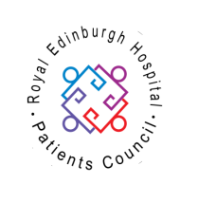 | The Royal Edinburgh Hospital Patients’ Council is a registered charity  Scottish Charity No SC021800  Our offices are situated off the Link Corridor in the Andrew Duncan Clinic  Website: www.rehpatientscouncil.org.uk

