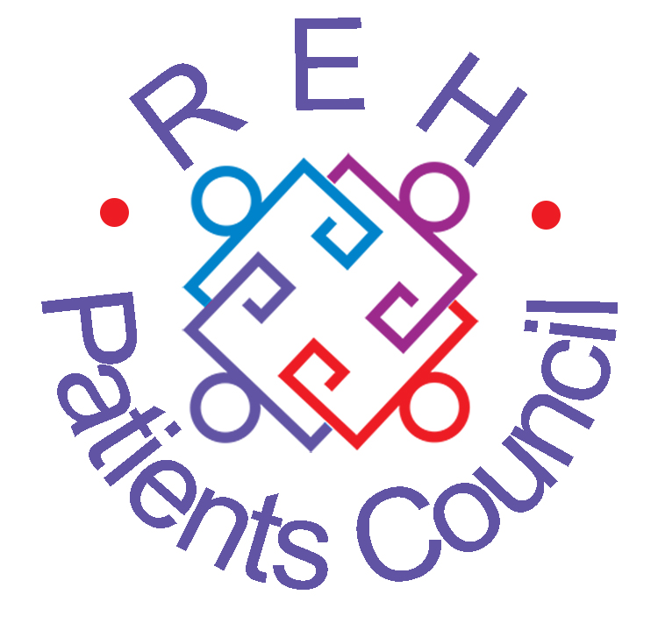
PATIENTS COUNCIL NEWSLETTER
May 2015
NEWS, VIEWS AND COMMENT FROM THE ROYAL EDINBURGH HOSPITAL
Patients Council Meeting
Monday 23 March 2015
17 people enjoyed an excellent presentation by Gary Hart, the Houses of Parliament Outreach Officer for Scotland and North West England. Gary aims to increase knowledge, awareness and understanding of the UK Parliament, encouraging people to get involved, to raise issues and use their voice. Some people cited examples of successfully using their MP to help them. Gary confirmed that the response is usually positive when people seek help from their MP.

Parliament’s website, www.parliament.uk offers lots of information about the work and history of Parliament, including the latest business information and news, guides to how Parliament works, an online tour and how to get involved with the democratic process. You can influence the work of Parliament by:
- Responding to a call for evidence from a Select Committee
- Contacting an all-party parliamentary group
- submitting a public petition to your MP
- Asking your MP, or a Member of the House of Lords, to raise an issue as a parliamentary question or as a subject of a debate in the House of Commons.
- Submitting evidence to a Public Bill Committee
- Contacting an MP or a Member of the House of Lords about a bill

Details of MPs can be found at www.parliament.uk, or from the House of Commons Information Office on 020 7219 4272, or at any town hall or library. You can raise any issue with your MP or a Member of the Lords.

We elected two new members to the Patients Council Management Committee – congratulations to Martin McAlpine and Ralph Turner.

We learned about a lecture in Edinburgh by Philip Day from Credence and the Campaign for Truth in Medicine. We debated the forthcoming ban on smoking in the hospital grounds. And we learned that Stories of Changing Lives II is now complete and on track to be launched at the Taking Stock conference on 28th May.

Group Advocacy
In April we:
- Attended the Lothian Mental Health Programme Board where we learned more about integration, locality planning and suggested more funding should go to psychological services.
- Got the first feedback about the implementation of the new smoking ban. Albany patients felt that bins should be placed at hospital entrances.
- Completed PQI (Patient Quality Indicator) surveys in Balcarres (female) and IPCU, speaking to patients about their experiences of standards on the wards.
- Learned about Art Therapy’s plans to include people with lived experience of mental health issues as co-facilitators in therapy sessions.
- Went to the CAMHS (Child and Adolescent) unit and heard that the young people would like to feel a lot more involved in their care and treatment.
- Heard that smoking on Balcarres (female) can be worse at night time and discussed the restrictions imposed on patients who have been designated ‘specified persons’.
- People who use The Hive said they would like it to be open more often and to serve a wider range of food and meals, not just snacks. It was felt that The Hive is a lot quieter since the smoking ban came into force.
- Discussed the different experiences of receiving social care and support from third sector providers before and after coming into hospital
- Played our part in the ongoing discussions about the future of Rehab care in Edinburgh.
- Facilitated visits to the wards by the GreenSpace Artspace co-ordinator to gather patients’ views on what they would like to see in the grounds of the new hospital.

www.rehpatientscouncil.org.uk Page 2

Stories of Changing Lives Two

The successor to ‘Stories of Changing Lives’ (imaginatively entitled ‘Stories of Changing Lives Two’!) will be launched at the “Taking Stock” meeting on the Heriot Watt campus on Thursday 28th May.

The central focus is again the series of autobiographical accounts of how those with severe mental difficulties came to terms with their problems and are now leading active lives in the community. The butterfly motif which visually encaptured their flight from hospital in volume one is also continued but with a different set of butterflies provided.

Essays from health professionals provide different kinds of support for the autobiographies. These include an overview of the Patients’ Council’s activities in the past year, an account of the Wayfinder initiative and an insight into the early developmental stages of the new hospital.

If you intend going to the ‘Taking Stock’ meeting, you should reserve a place as soon as possible, as this is a popular event.

The smoke Free Hospital

At the time of writing, the new smoking policy has been in place for just over a month, so here are our first impressions. As you might expect for such a potentially polarising issue, views on how successfully the implementation has gone depends on who you speak to. Predictions of back-lashes and fighting in the streets don’t seem to have come true, but neither have the wards and grounds become oases of fresh air and tranquillity. Unfortunately, there have been some altercations and we are hearing about an increase in the amount of smoking on the wards. On the plus side, the courtyards and gardens have become more pleasant areas for many people to enjoy and some patients have been able to quit smoking entirely. Patients have told us that they think bins for disposing of cigarette butts should be provided at the entrances.
Some people still feel the policy is draconian and at least one local mental health lawyer has suggested that it may be possible to challenge the policy in the courts on the basis of human rights considerations, e.g. by using the principle of proportionality. Contact us for further details.
www.rehpatientscouncil.org.uk Page 3

The Royal Edinburgh Hospital
Patients’ Council
The Patients Council is an independent collective advocacy project for people who use or have used the services of the hospital. We provide a forum for common issues about mental health treatment and care and represent patients’ interests in order to improve services. We hold general meetings every two months. To get involved with mental health issues from the service-user’s viewpoint, contact our staff.

Telephone: 0131 537 6462
Email: info@rehpatientscouncil.org.uk

Write: The Patients’ Council, Royal Edinburgh Hospital, Morningside Terrace, EH10 5HF

Our Management Committee
Shirley Gowers, Ronnie Jack,
Albert Nicolson, Martin McAlpine, Alison Robertson, Ralph Turner, Patricia Whalley

Co-opted member:
Cathy Robertson
PATIENTS COUNCIL MEETINGS
2015
2 – 3.30pm

26 January

23 March

25 May

27 July

28 September

30 November:
Annual General Meeting
1.30 – 3pm in The Hive
followed by buffet

History of the Patients Council
A few of our members have written a history of the Royal Edinburgh Hospital Patients Council highlighting some of our activities since 2000. Please contact us for a copy.

To receive the newsletter direct, by post or e-mail, please complete and return this section.
I would prefer to receive the Newsletter by post □ email □ (tick as appropriate)
Name ____________________
Address_______________________________________________ Post code_____
Email__________________________________________________________________________

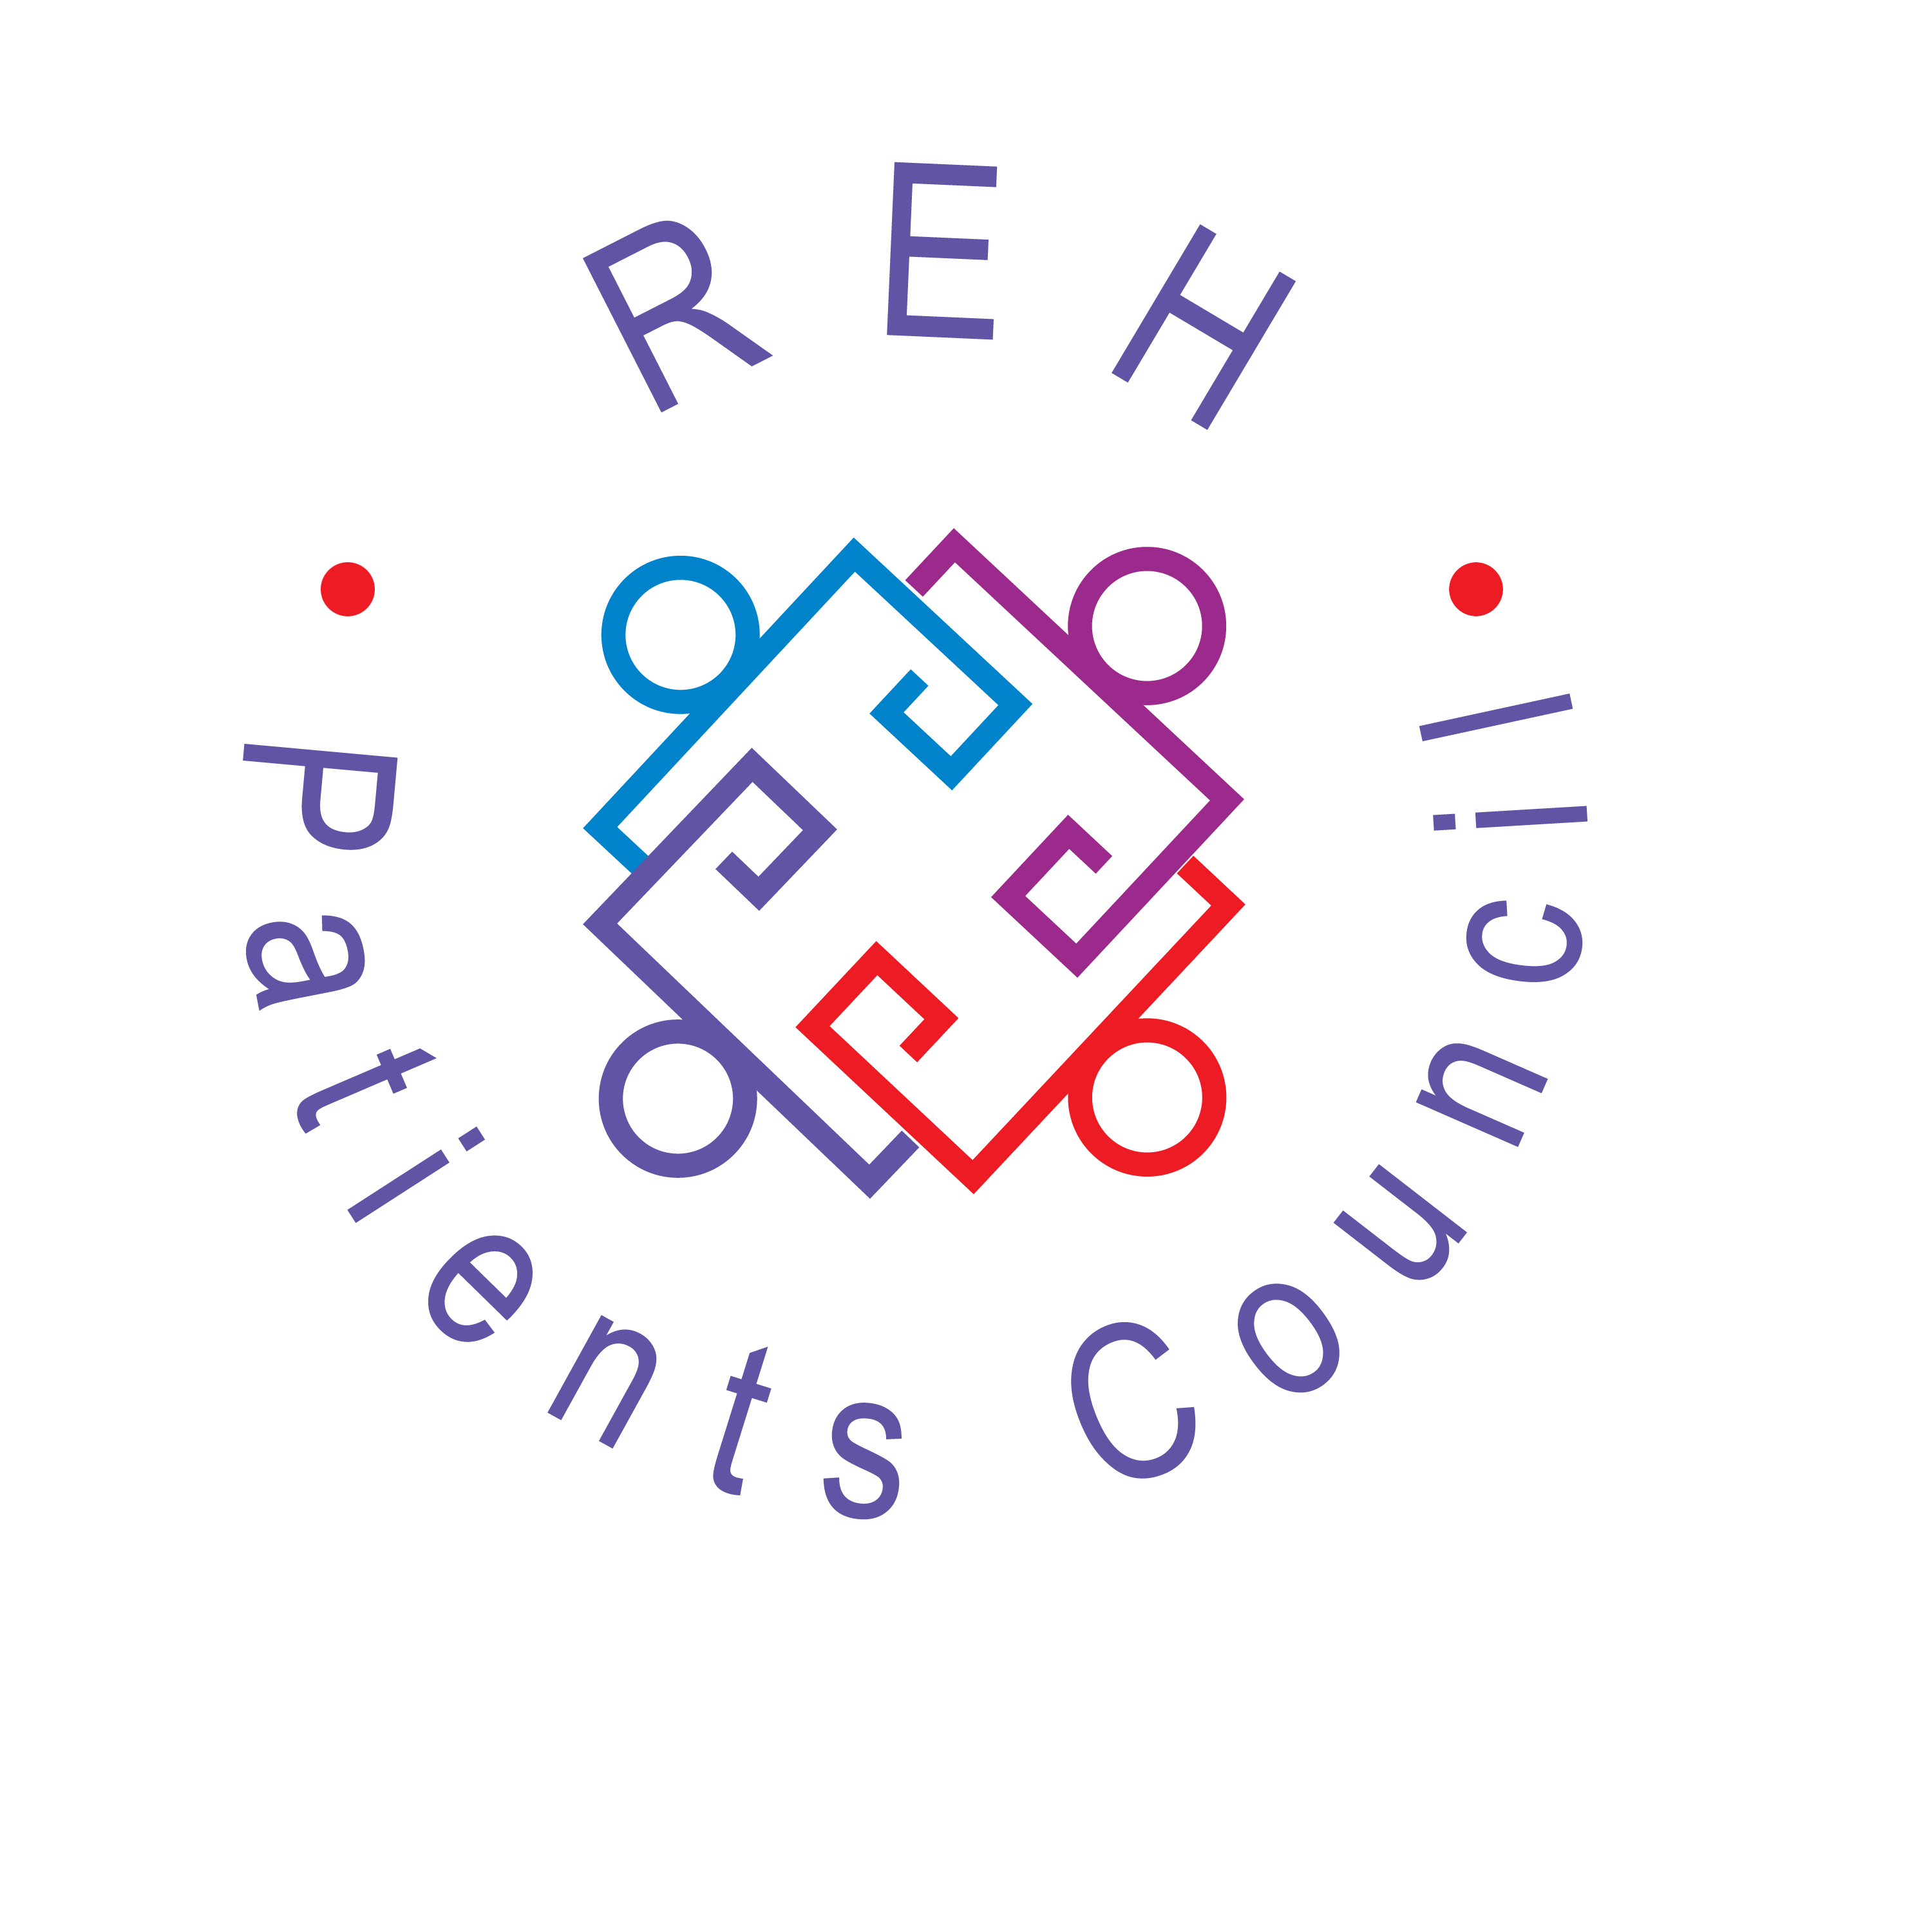
The Royal Edinburgh Hospital Patients Council is a registered charity
Scottish Charity No SC021800
Our offices are between Outpatients and Mental Health Tribunal in the ADC
www.rehpatientscouncil.org.uk

www.rehpatientscouncil.org.uk Page 4

All patients, former patients, staff and visitors are warmly invited to attend

PATIENTS COUNCIL MEETING
from 2.00-3.30pm on
Monday 25 May 2015
in The Hive

Linda Irvine, Strategic Programme Manager, Mental Health & Wellbeing, NHS Lothian
will be speaking about Public Social Partnerships with NHS Lothian

