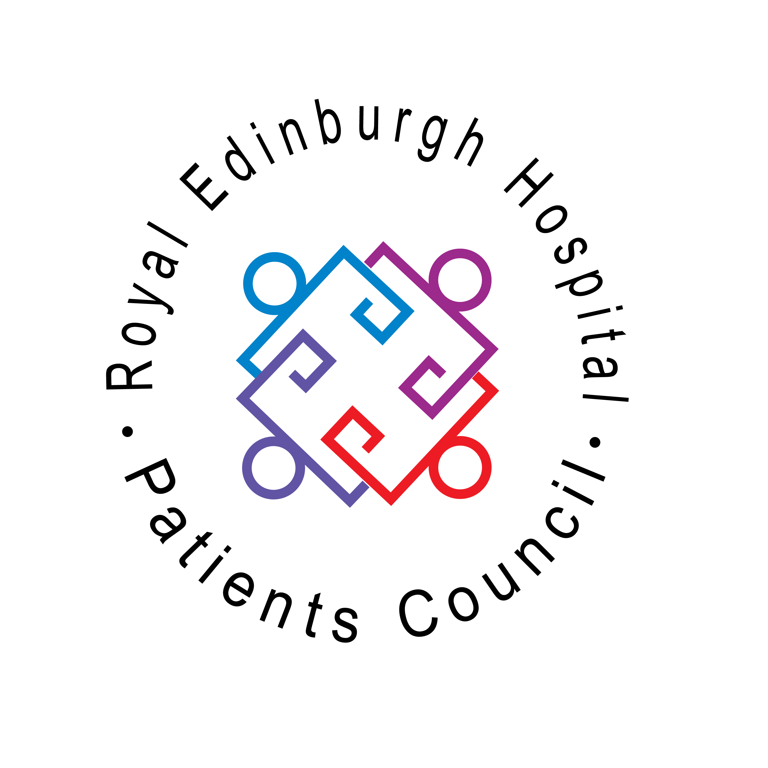
ROYAL EDINBURGH HOSPITAL PATIENTS’ COUNCIL
Morningside Terrace, Edinburgh EH10 5HF
Telephone: 0131 537 6462 Fax: 0131 537 6409
maggie.mcivor@patientscouncilreh.co.uk
www.patientscouncilreh.co.uk
Registered Charity – Scottish Charity No. SC021800

Annual Report April 2010 – March 2011

Our Charity Trustees at date of signing the Annual Report
Shirley Gowers
Tony Davis (from 26 September 2011)
Carol Manley
Albert Nicolson
Alison Robertson
Patricia Whalley

Names of all other charity trustees during the period 1 April 2009 to 31 March 2010

Kate Cullen (until 31 August 2011)
Elaine Dobbie (until 31 December 2010)
Ian Hughes (until 29 November 2010)
Marie Jenkins (until 29 November 2010)
Bruce McNally (from 29 November 2010 until 24 January 2011)
Charlotte Mitchell (until 29 November 2010)

Signed: _______________________ Date:
Chair, Patients’ Council

Signed: _______________________ Date:
Vice Chair, Patients’ Council

Structure, Governance and management

Type of governing document
The Royal Edinburgh Hospital Patients’ Council (PC) is an unincorporated association. It is an independent collective advocacy service for patients and former patients of the Royal Edinburgh Hospital and associated community mental health services. Every patient and former patient is a member of the Patients’ Council.

Trustee recruitment and appointment
Members interested in joining the management committee are interviewed by the office-bearers to:
- inform them about Patients’ Council work
- inform them about the roles and responsibilities of management committee members
- ensure their ability to fulfil the commitments
- identify any specific areas of interest they may have
- explain and sign the Patients Council activist agreement

Prospective candidates are nominated and seconded by members of the PC at the AGM. Members present at the AGM elect up to 12 committee members.
The same process is used to fill any vacancies during the year, with elections taking place at PC Meetings, held every two months.

Objectives and activities

Charitable purposes
- To promote the rights of patients and former patients
- To address concerns raised by patients and former patients about services
- To resolve these concerns by working jointly to encourage changes and developments in services with hospital staff and management
- To facilitate the representation of patients’ and former patients’ views and opinions to the hospital, to health service management and to statutory organisations, as appropriate
- To act as a link with other patient groups and networks locally and nationally
- To raise awareness of the views of patients and former patients and collective advocacy issues at training events, conferences and other forums.

Summary of main activities in relation to the objects
Patient issues are brought to the attention of the PC in different ways. These include:

- Open PC Meetings which are held every two months at the Royal Edinburgh Hospital
- regular collective advocacy meetings held with patients on individual wards
- by letter, telephone or by calling into the office
- from individual advocacy staff
- distribution and collection of questionnaires
- direct personal experience of members

These issues are addressed and patient opinion expressed through:

- attending a wide variety of NHS review and development meetings in the Royal Edinburgh Hospital
- attending consultation and networking events outwith the Royal Edinburgh Hospital
- writing letters
- producing reports
- working directly with a range of staff
Summary of main achievements 2010 - 2011

Collective Advocacy in Care of Older People and Children & Adolescent Mental Health Services

With funding from Endowments for one year, we extended collective advocacy services on a part-time basis to the Care of Older People Service and the Children & Adolescent Mental Health Service starting January 2010. We began planning how we could further core fund the work when City of Edinburgh Council (CEC) announced they wanted a review and then a competitive retendering of independent advocacy services in Edinburgh. As the Patients Council was not funded by CEC we thought the project would not be included. Then in November 2010 the NHS announced they would join in with the competitive retendering but would reinvest any money they saved. The results of the tender fall outwith the timescales of this report. What we can say is our host agency Advocard won the contract, working in partnership with the PC and Carers Council. But we are left with doubts over the work continuing in CAMHS and Older People’s service due to resulting budget restraints.

During the initial period from April 2010 to March 2011, we:

- Consulted staff in the Individual Advocacy project and Edinburgh Carers Council
- Attended relevant training opportunities
- Furthered good working relationships with Clinical Services Development Managers in both services – both proved to be an invaluable source of information, advice and support
- Furthered good working relationships with nursing and OT staff in both services, to assist in planning and delivery of the Groups where appropriate
- Developed working protocols with the hospital Individual Advocacy service
- Recruited a pool of volunteers with lived experience to take an active role in the project, especially in encouraging patients to have their say
- Arranged Disclosures for both our staff and our volunteers
- Continued Collective Advocacy Groups in both services
- Bedded in new ways of working in both services to enable issues to be brought to the Patients Council.
- We were pleased to be able to assist the hospital by running patient focus groups as part of the current evaluation of Nile ward, and look forward to receiving the results of this interesting and valuable example of collaborative working. The Occupational Therapist who asked us to get involved, Margaret Williamson, had this to say:

“The funding for a collective advocacy service just over a year ago has given our older people the first opportunity to have a collective voice with the potential to influence the services they receive. Nile Ward, in particular, is unusual in its specific focus on a ‘recovery’ oriented approach to rehabilitation for older people. The success
of this approach depends heavily on service user involvement and empowerment through an active process of collaboration with services. I am aware that this approach is supported throughout all tiers of our organisation.

On Nile ward over the past year, collective advocacy have facilitated regular meetings with service users regarding their experiences and communicated the results of these meetings with the organisation. In addition, they collaborated with myself to undertake an evaluation project looking at the service user perspective on what the ward does, what service users think about it, and whether it helps. The resulting project
used a focus group design facilitated by collective advocacy using a specific protocol (researched and ethically reviewed to achieve high standards of data).

I am still in the midst of writing this project up, but it is very clear at this stage that the involvement of collective advocacy as impartial group facilitators significantly enhanced the open sharing of information, thoughts and opinions and thereby, the validity of the subsequent data. Themes emerging concern activity provision, information, environment and engagement with staff.”

Collective Advocacy and User Involvement in all other areas of the hospital

Here are some examples. This year we:
- started regular collective advocacy meetings on Acute Wards
- Continued to bed in collective advocacy meetings on rehab wards
- Contributed feedback to the review of independent advocacy in Edinburgh
- Worked in partnership with Dr Joanna Bredski, specialist registrar. Our volunteers collected rehab patient feedback through questionnaires. This work is similar to the Acute Ward questionnaires the PC carried out for the NHS in partnership with Emma Doyle in 2010. The PC members continue to learn what works well and what the challenges are when collecting feedback in this way, building on their already established strengths

Project Development

Some examples of our development work are:
- We have continued to build on our productive working links with all REH staff and created new links and ways of working. The PC would like to acknowledge all staff providing opportunity for members to be involved and supporting collective advocacy. We want to thank them all.
- We have continuously developed our quarterly reports to give even clearer information on key areas. This includes capturing more statistical information. We also developed our ways of capturing collective advocacy issues and recording outcomes.
- We designed and launched a new website
- We developed new strategies for distributing newsletters and information within the hospital
- Contributing to the CEC/NHS advocacy review by providing patient opinion to a consultation on the proposed models of advocacy
- The Management Committee had an away day. The day provided opportunity to celebrate the huge range of work our management cover and examine our collective issue referral and handling pathways. This resulted in producing a ‘rainbow pathway of influence’ graphic
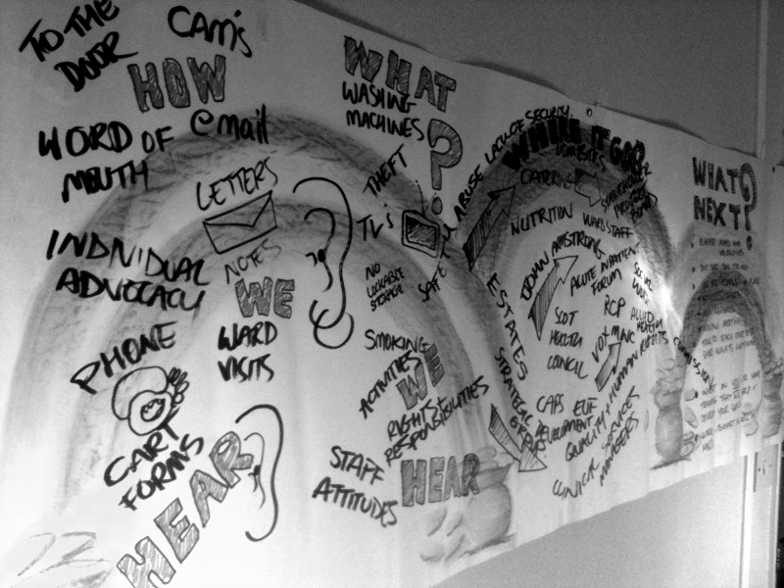

Financial review
Brief statement of policy on reserves
An underspend occurred due to the Patients council members and staff managing a tight budget extremely well. Often the PC looks for discounted or free services. The
Patients Council retains money as a reserve.

Donated facilities and services
Accommodation and computer facilities are provided free of charge by NHS Lothian.

Supported by Funded by:


