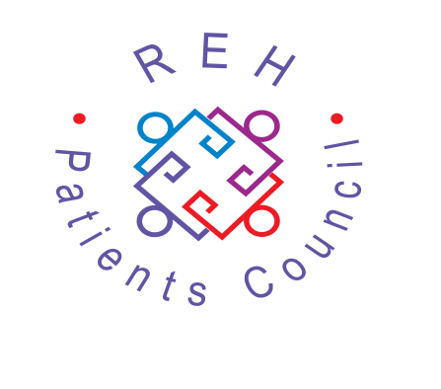

Royal Edinburgh Hospital
Patients Council
ANNUAL GENERAL MEETING
Monday 25 November 2019
Ward 11 Seminar Room,
2nd Floor, Mackinnon House,
Royal Edinburgh Hospital
1.30 – 3pm
Guest Speaker:
Nickola Jones,
Strategic Programme Manager

NICKOLA WILL DISCUSS HER ROLE & HOW IT FITS IN WITH THE REH & INTEGRATED JOINT BOARD, WHAT THIS CAN MEAN FOR IN-PATIENTS & ANYONE WHO HAS ACCESSED THE SERVICES OF THE REH.
QUESTIONS WELCOMED BY NICKOLA AFTER HER TALK.
All welcome!
Royal Edinburgh Hospital Patients Council
Morningside Place, Edinburgh EH10 5HF
Telephone: 0131 537 6462 Fax: 1031 537 6409
E-mail: info@patientscouncilreh.org.uk
Registered Charity No. SC021800
www.patientscouncilreh.org.uk

