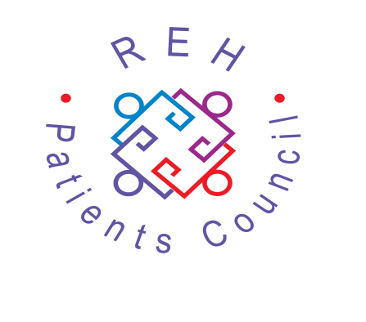

Royal Edinburgh Hospital
Patients Council
ANNUAL GENERAL MEETING
Monday 30 November 2020
2.00-3.30pm via Zoom invitation

Guest Speaker: Mr Ed Jesudason,
Consultant in Rehabilitation Medicine, NHS Lothian, & Medical Ethics Tutor, University of Edinburgh, who will be giving a talk-‘How can rights-based advocacy improve medical practice?’
Followed by a Q & A session.

All welcome, numbers limited due to Zoom restrictions, please contact either info@rehpatientscouncil.org.uk or Carolyn@rehpatientscouncil.org.uk
to request a place!
Royal Edinburgh Hospital Patients Council
Morningside Place, Edinburgh EH10 5HF
Telephone: 0131 537 6462/6317
Registered Charity No. SC021800

