Bi-monthly News, Views & Comment from inside and out the Royal Edinburgh Hospital

PATIENTS COUNCIL MEETING
2.00-3.30PM
MONDAY 2 AUGUST
BOARD ROOM, ROYAL EDINBURGH HOSPITAL

COME ALONG AND MEET

Mandy Scott
Peer Support Worker

Mandy will be telling us about the peer support work she is doing in the Royal Edinburgh Hospital and answering any questions.

WELCOME

The meeting is open to everyone who is using or has used the services of the Royal Edinburgh Hospital.

Refreshments will be provided

Volunteer Centre Edinburgh
Inspiring Volunteering Awards 2010

We are delighted that the Royal Edinburgh Hospital Patients’ Council Management Committee has won an Inspiring Volunteering Award! These awards celebrate the achievements of volunteers and the difference they have made to the people they work with, recognising their commitment, creativity and determination to overcome personal difficulties to help others.

The Patients Council provides independent collective advocacy at the Royal Edinburgh Hospital to make life more rewarding and fair for patients by helping them to express their own needs, opinions and aspirations and make informed decisions. It ensures that hospital staff and management are made aware of their views and works in partnership with them to achieve satisfactory outcomes. Partnership working has proved to be by far the best way to achieve improvements. The Patients Council is run by and for service users. The Management Committee members give up their free time voluntarily to try to make a difference for people still in the hospital. They guide and participate in the work of the Council, which ranges from visiting patients on wards to attending meetings with hospital and NHS Lothian managers. They express service user views to senior managers with confidence, determination and endless perseverance.

With only two members of staff, the Patients Council depends on its volunteers. The commitment shown by the members of the Management Committee is incredible. They take on difficult, challenging tasks and use their lived experience to help improve services in the hospital and to improve the lives of patients. They have made an enormous difference. Many changes have taken place because a patient has felt comfortable enough to raise an issue with one of our volunteers. Improvements have been made to the food, the ward environment, relationships with staff, activities on the ward – the list is endless. And they give service users an opportunity to express their views on wider issues, such as smoking in the hospital. They make sure they are listened to and that the voice of mental health service users is heard loud and clear. They are accomplished at representing the majority view (even if at times they disagree with it!) – true ambassadors for collective advocacy.

Involvement with the Patients Council can really help service users to develop their skills and confidence and move on with their lives. One of their members recently produced an inspirational book called ‘Stories of Changing Lives’. It tells the stories of people who moved into the community in the late 1990’s after years of living in the hospital. It was produced virtually single-handed – and its author is now in full-time employment. The Patients Council is proud to have provided one step on this wonderful journey of recovery.

Alison Robertson, our Vice-Chair, and Marie McGraw, Management Committee member, attended the Inspiring Volunteering Award Ceremony at the Edinburgh City Chambers on Thursday 3rd June where they were presented with their award by Rt. Hon George Grubb, Lord Provost of Edinburgh.

Patients’ Council Newsletter
Page 2

What Our Activists Have Been Doing

Our volunteers have been involved in a range of collective advocacy meetings over the last couple of months. Two people took part in assessments for third year mental health nursing students at Edinburgh Napier University, as well as interviews for new applicants to the course. Several members have taken part in the on-going review of advocacy. They have attended a variety of other meetings, from Mental Health Nursing Implementation to Peer Support to Smoking Cessation.
Keep up the good work!

Below is an abstract from our latest progress reports. For a copy of the full reports please contact the Patient Council Office or visit our website www.patientscouncilreh.org.uk

COMMUNICATION
The PC has been pleased to offer a volunteer the opportunity to be involved with the development of the new PC website. The new website will hopefully not only communicate the achievements of the PC better, to users and staff, but also grow into a catalogue of these achievements and all the work done.
The PC continues to communicate with a wide range of patients, staff and services so the opinions and concerns of patients reach decision makers. As the collective advocacy meetings continue to bed in on wards, it offers opportunity for staff and patients to experience the benefits of Collective Advocacy and the unique Patients Council perspective provided by its committed volunteers. Volunteers continue to contribute reports and participate in improvements to systems internally, supporting better communication within the PC. The PC has regular meetings with senior staff and has over the last three months re-established feedback links with domestic services.
Patients’ Council Newsletter
Page 3
Our last Patients Council Meeting
Monday 24th May 2010

We had a super session with Fraser and Laura from The Hive’s Community Links Project which is being funded for five years to meet the needs of people who had been returning to the hospital after discharge because they were having difficulty accessing suitable services in the community. Fraser and Laura support people for up to six months after discharge, focussing on their social needs – faith & meaning, art, education, employment, volunteering and sports. They help people to access resources, especially mainstream resources, which are already available in the community. They try to find services to suit patients, rather than making patients fit services.

Stories of Changing Lives

If you would like a free copy of the ‘Stories of Changing Lives’ booklet, please contact the Patients’ Council office. Or visit our website to read a copy online.
CAMHS & Care of the Elderly Project
We are now working in all eight Care of Older People’s wards, as well as the CAMHS In Patient Unit, Day Programme and Forteviot. We have held two very successful meetings with friends, carers and relatives on the two continuing care wards for people living with dementia, jointly hosted by Edinburgh Carers Council.

Tom Carey, a founder member of the Patients Council, sadly passed away last month, following a long illness. Tom was a very well-known and vociferous member of the user involvement movement in Edinburgh right from its beginnings way back in the 1980s - and still representing patients’ views at a Patients Council Meeting the week before he died. We miss you, Tom.
Self Portrait

The years I wept,
wishing that my days would cease to be

The hours I begged
for some Almighty hand to set me free

The lifetime now ahead
to get to grips with loving me

written for The Patients’ Council
by Jo McFarlane, 5th July 2010

-------------------

Friends Re-ignited
(Jo McFarlane and Rachel McCluskey)
will be presenting

The Head Girl, the Gap Year and Sue Ellen

as part of the Free Fringe

8.40 – 9.40pm
7th to 17th August

The Banshee Labyrinth
29-35 Niddry Street

(Free Non-ticketed)

Page 4
The Royal Edinburgh Hospital Patients’ Council
is an independent collective advocacy project for people who use or have used the services of the hospital. We provide a forum for common issues about mental health treatment and care and represent patients’ interests in order to improve services. We hold general meetings every two months. To get involved with mental health issues from the service-user’s viewpoint, contact our Project Manager, David Budd or Development/Admin Worker, Maggie McIvor.
Telephone: 0131 537 6462
Email: maggie.mcivor@patientscouncilreh.org.uk
david.budd@patientscouncilreh.org.uk
Write: The Patients’ Council, Royal Edinburgh Hospital, Morningside Terrace, EH10 5HF

Our Management Committee:
Patricia Whalley (Chair); Elaine Dobbie (Convenor of Management Committee); Alison Robertson (Vice Chair), Kate Cullen, Shirley Gowers, Ian Hughes, Marie Jenkins, Carol Manley, Charlotte Mitchell, Albert Nicolson. Co-opted members: Cathy Robertson, Leah Marchbank, Ross McPhail, Alan Muir

Patients’ Council Meetings 2010
Mondays : 2 – 3.30pm : Board Room
2nd August and 27th September
Annual General Meeting 2010
1.30–4pm : Board Room
Monday 29 November

Patients’ Council Newsletter

The Royal Edinburgh Hospital Supported by AdvoCard Funded by:
Patients’ Council
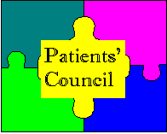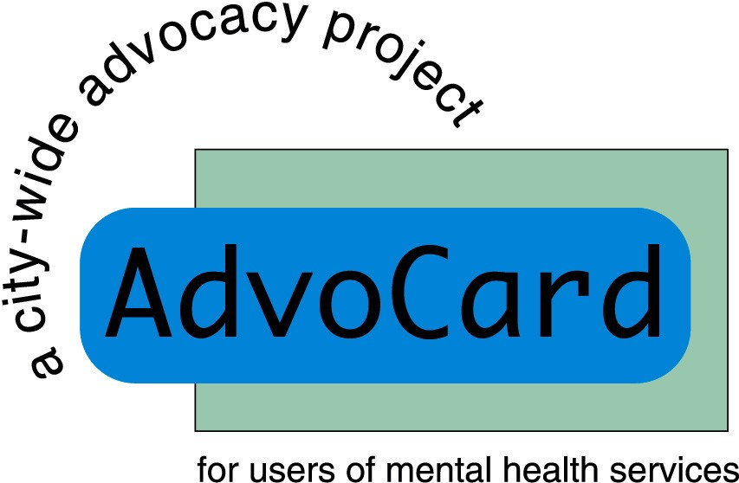

The Patients’ Council is a registered charity, Scottish Charity No SC021800
Our offices are situated off the Link Corridor in the Andrew Duncan Clinic
Website: www.patientscouncilreh.co.uk

To receive the newsletter direct, by post or e-mail, please complete this section and return it to our Development & Administration Worker, Maggie McIvor.
I would prefer to receive the Newsletter by post/email (delete as appropriate)
Name _______________________________________________________

Address_____________________________________________________________________________

Email ______________________________________________________________________________

