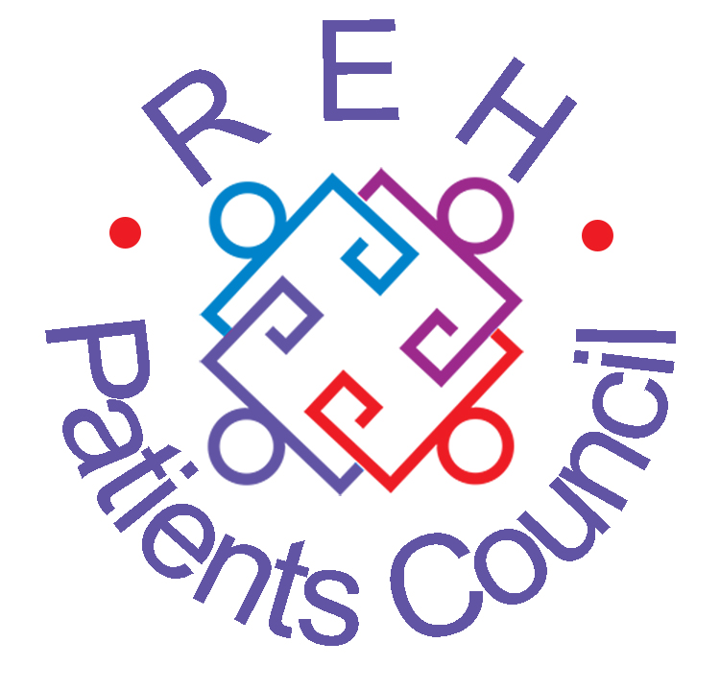
PATIENTS COUNCIL NEWSLETTER
September 2014
NEWS, VIEWS AND COMMENT FROM THE ROYAL EDINBURGH HOSPITAL
Patients Council Meeting
Monday 28 July 2014
Our guest speaker was Linda Irvine, the Strategic Planning Manager for Mental Health, NHS Lothian. Linda is coordinating the Green Space Art Space initiative, which aims to promote the effective use of outdoor space on the new hospital campus. Along with her colleagues Jennifer Thwaites, Jo Northedge and Dick Fitzpatrick, Linda has been gathering feedback from people about what they want from the new hospital. The key points which have emerged include creating green areas on the campus, promoting a safe environment, providing good lighting and offering activities for patients and staff. The use of social (not-for-profit) firms will hopefully provide employment opportunities for service users, and there should also be plenty of volunteering opportunities.

Since the hospital caters for such a wide range of people, the challenge is to create a safe, engaging new campus which will benefit everyone.

The Green Space Art Space team hope to provide seating throughout the site. Work has already begun on the Growing Plots, and a sensory garden is also being planned. Other plans include participative arts and crafts, perhaps using pop-up exhibitions in different venues, and outdoor sport and leisure areas. There have been lots of other great suggestions – such as bee-keeping!

To get involved or contribute ideas to the project, you can contact the Patients Council or attend the Green Space Art Space Meetings.

Thankyou Linda, for an excellent talk!

Collective Advocacy

At the Collective Advocacy meetings, we have been discussing the shortage of beds and the lack of things to do on the wards, especially at weekends. There are not enough Occupational Therapists, and it would be helpful to have activities off the wards as well, such as guided walks.

Many patients feel that there are not enough nursing staff on the wards.

Other issues include smoking on wards, theft, access to patient computers and the provision of healthier foods, including snacks.

Many patients feel that there is not enough information provided on admission to the hospital. It would be useful for new patients to have more information about things like the Hive, Artlink, the library, advocacy provision, and the opening hours of the shop and fruit stall, for example.

There have also been concerns about maintenance on the wards, with difficulties including leaky taps, heavy doors which slam, faulty showers and broken tumble dryers.

Another issue which has been raised is that patients feel they are not seeing their consultants often enough and are often unsure of what is supposed to be happening.

Aggressive behaviour on the wards is also a problem – patients are often uncertain about what to do if they feel threatened or frightened by another patient.

Volunteers attended a Substance Abuse meeting. Solutions were discussed to help deal with the prevalence of legal highs in the hospital, which is becoming a serious problem.

Our volunteers have also been attending Green Space Art Space meetings, such as Green Play Green Exercise.

We have also been attending various other meetings, such as Wayfinder PSP and REH Nutrition Group.

www.rehpatientscouncil.org.uk Page 2

GreenSpace|ArtSpace
GreenSpace|ArtSpace is a Public Social Partnership, which is part of the Royal Edinburgh Hospital campus redevelopment. Over the next couple of years partners, who include service users, staff, organisations and the wider community, will be designing the layout of the new green spaces and art spaces within the hospital campus to provide exciting new therapeutic spaces and opportunities.

The GreenSpace|ArtSpace project is split into four focus areas to explore the development of spaces and activities around:
- Growing and Eating
- Environmental and Participative Arts and Crafts
- Green Exercise and Green Play
- Integrated Art and Design

The groups have begun to meet on a regular basis to start the design and production process. If you would like to find out more about how you can be involved and share your ideas please contact Jo Northedge or Jen Thwaites at rehcampus@nhslothian.scot.nhs.uk or 0131 441 8000

Over the next few weeks, Jen and Jo will be visiting the wards in the REH along with the Patients’ Council to introduce the project in more detail and to start to learn about what you would like to see and be involved in within the GreenSpace|ArtSpace project.

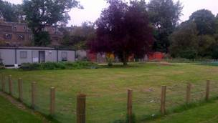

The new growing space at the REH will be designed through our growing and eating group. We’d love to hear your design ideas!

Our new Project Coordinator

We are delighted to announce that Simon Porter has joined us as Project Coordinator. Simon has worked extensively in individual and collective advocacy in Glasgow, as well as having lived experience of mental health issues. We are all really looking forward to working with him at this very busy time. A very warm welcome, Simon!

www.rehpatientscouncil.org.uk Page 3

The Royal Edinburgh Hospital
Patients’ Council
The Patients Council is an independent collective advocacy project for people who use or have used the services of the hospital. We provide a forum for common issues about mental health treatment and care and represent patients’ interests in order to improve services. We hold general meetings every two months. To get involved with mental health issues from the service-user’s viewpoint, contact our staff.

Telephone: 0131 537 6462
Email: info@rehpatientscouncil.org.uk

Write: The Patients’ Council, Royal Edinburgh Hospital, Morningside Terrace, EH10 5HF

Our Management Committee
Shirley Gowers, Ronnie Jack,
Albert Nicolson, Alison Robertson, Patricia Whalley

Co-opted member:
Cathy Robertson
PATIENTS COUNCIL MEETINGS
2014
2 – 3.30pm in The Hive

27 January

24 March

26 May

28 July

29 September

24 November:
Annual General Meeting
1.30 – 3pm in The Hive
followed by buffet

History of the Patients Council
A few of our members have written a history of the Royal Edinburgh Hospital Patients Council highlighting some of our activities since 2000. Please contact us for a copy.

To receive the newsletter direct, by post or e-mail, please complete and return this section.
I would prefer to receive the Newsletter by post □ email □ (tick as appropriate)
Name ____________________
Address_______________________________________________ Post code_____
Email__________________________________________________________________________

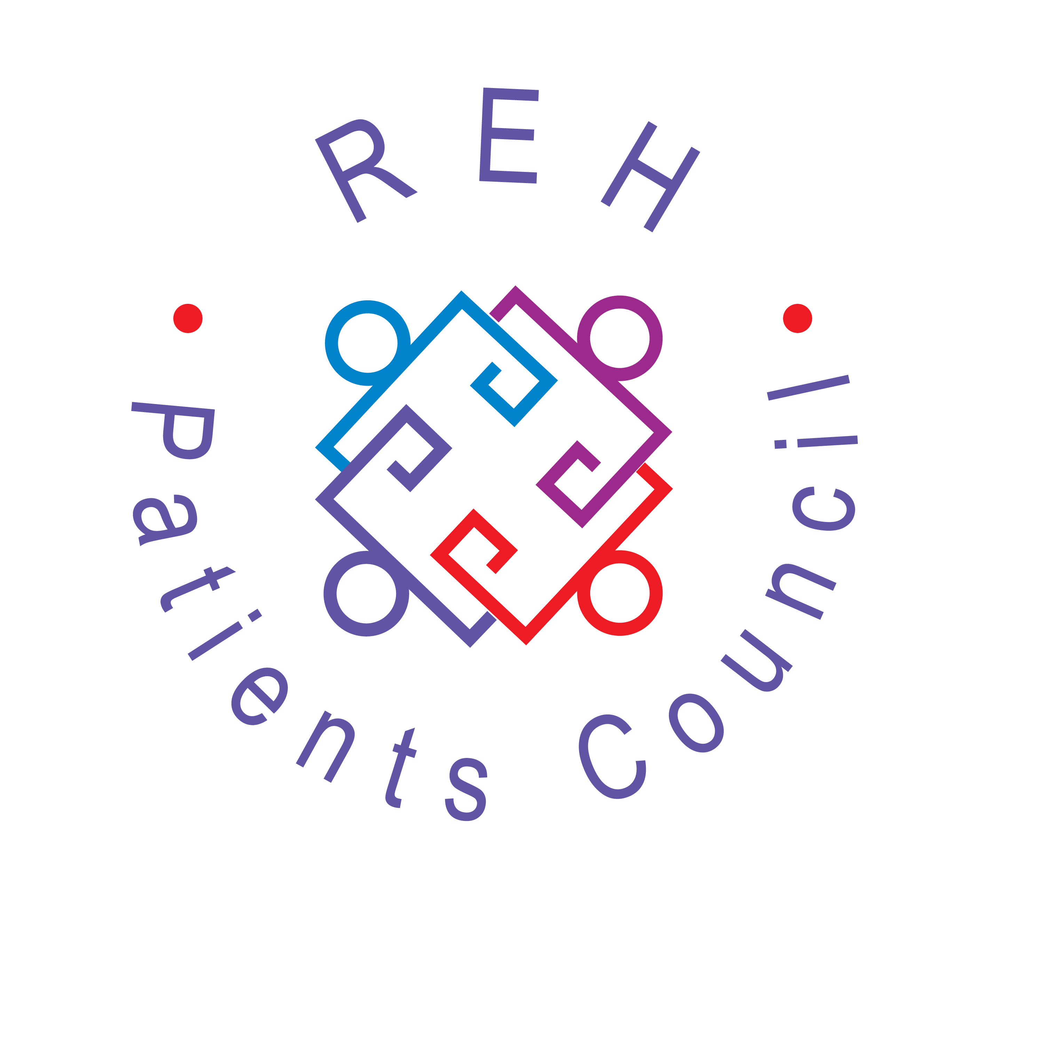
The Royal Edinburgh Hospital Patients Council is a registered charity
Scottish Charity No SC021800
Our offices are between Outpatients and Mental Health Tribunal in the ADC
www.rehpatientscouncil.org.uk

www.rehpatientscouncil.org.uk Page 4

All patients, former patients, staff and visitors are warmly invited to attend

PATIENTS COUNCIL MEETING
from 2.00-3.30pm on
Monday 29 September 2014
at The Hive

Linda Cullen, SEAN National Clinical Co-ordinator will be coming to speak about the work done by the Scottish ECT Audit Network (SEAN)

Please join us for a cuppa!

